Image’s Objects Detection

Chuong Nguyen

CST-451 Capstone Project Requirements Document

Grand Canyon University

Instructor: Professor Mark Reha

Revision: v2.0

Date: 03/20/2019

**ABSTRACT**

This application uses TensorFlow to detect multiple objects in an image. From web application, user can input image from local computer or Raspberry Pi Camera. The object detection algorithm will return name of objects in the image. All of image, object detected will be save on database.

|  |
| --- |
| History and Signoff Sheet |

**Change Record**

|  |  |  |
| --- | --- | --- |
| **Date** | **Author** | **Revision Notes** |
| 09/21/18 | Chuong Nguyen | Project Requirements |
| 03/30/19 | Chuong Nguyen | Update project requirements |
|  |  |  |

|  |
| --- |
| **Overall Instructor Feedback/Comments**  Create functions to search images contains specific objects from multiple images  Draw bounding box for the object in the image. And let the users choose which object they want to draw. |

|  |
| --- |
| **Overall Instructor Feedback/Comments** |

**Integrated Instructor Feedback into Project Documentation**

Yes  No

**TABLE OF CONTENTS**

Functional Requirements 4

Non-Functional Requirements 8

Technical Requirements 10

Logical System Design 11

User Interface Design 12

Reports Design 17

Functional Requirements

Overview

The main functions of this program includes:

1. Create a web application with login and register function
2. Only logged in user can perform tasks on the application
3. Input and detect objects in the image
4. Stream video and detect objects in the video
5. Save images and objects in to database
6. Capture the video stream and save into database.
7. Classify images from multiple images.

Use case diagram:

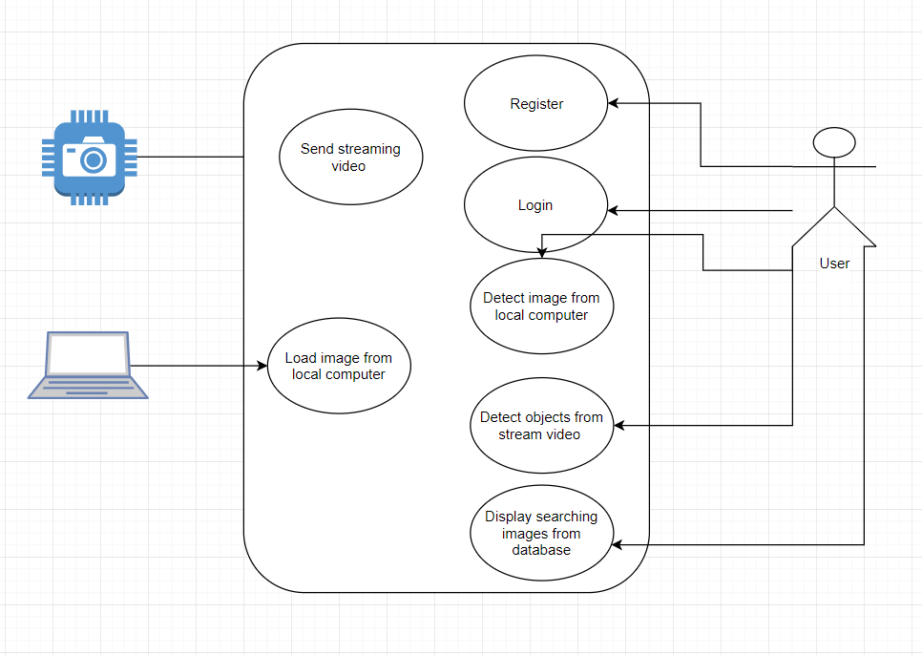

Site map:

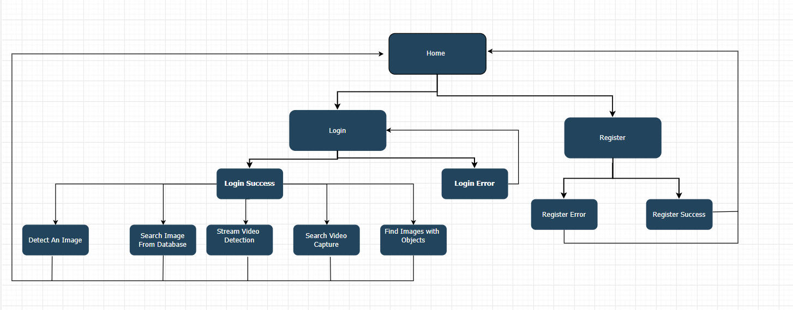

User stories:

|  |  |  |  |  |
| --- | --- | --- | --- | --- |
|  | | | **User Stories** | |
| **ID** | **Features** | **As a(n) <actor>** | **I would like to <description>** | **So that outcome** |
| 1 | Registration | User | I would like to register on website before login | I can get a username and password |
|  |  | User | I would need user input all required fields for registration | I have full user information |
|  |  | System | I would like to refuse user register with username which already exist in system | Username is unique |
| 2 | Login | User | I would like to input username and password | I can access the website |
|  |  | System | I would like to check username against credential store | I can verify user |
|  |  | System | I would like to display a login error page if input username is incorrect | So website is not accessible |
|  |  | System | I would like to display a login error page if input password is incorrect | So website is not accessible |
|  |  | Admin | I would like to input admin username and password | I can get Admin functionalities. |
| 3 | Log out | User | I would like to log out my login session | Application does not keep my login when the other user use it |
|  |  | Admin | I would like to log out my login session | Application does not keep my login when the other user use it |
| 4 | Input image from local computer | Admin | I would like to hide detect objects functional from guest user | Only login user can detect object from image |
|  |  | User | I would like to have options to choose input image from local computer | I can go to input image from local computer page |
|  |  | User | I would like to click input image button to open local computer to find image location | I can choose image to input to application |
|  |  | User | I would like to click detect button to process image detection | I can detect objects of the image |
|  |  | User | I would like to input another image after detect an image | I can detect multiple images |
|  |  | User | I would like to see notice to input image when I click detect button without image input | Remind me input image to detect objects |
|  |  | System | I would like to display error when user input non image file | Require user input image file |
| 5 | Object detection processing from local image | User | I would like to display name of objects along with objects in the image when I click detect button | I can know what objects in the image |
|  |  | User | I would like to see a table to display a list of objects in the image | I can see the results in detail |
|  |  | User | I would like to see the percentage of accuracy of object detected | I can analyze the object detection |
|  |  | User | I would like the result of detections has accuracy > 50% | I can test the performance of object detection algorithm |
|  |  | Admin | I would like to store the image and it’s objects into database after detection | I can save data into database |
| 6 | Input from Camera | User | I would like to have option detect objects from camera’s stream video | I can test application in real time device |
|  |  | User | I would like to display livestream video | I can display livestream video |
|  |  | User | I would like to capture image from camera | I can use this image to input to detect objects in it |
|  |  | User | I would like to display error when there is no camera connection | Remind user plugin Camera |
| 7 | Object detection processing from Camera | User | I would like to display name of objects along with objects in the image which took from Camera | I can know what objects in the image |
|  |  | User | I would like to display name of objects in the live stream video | I can know what objects in the camera |
|  |  | User | I would like to see a list of objects in the image | I can see the results in detail |
|  |  | User | I would like to see the percentage of accuracy of object detected | I can analyze the object detection |
|  |  | User | I would like the percentage of object detection > 50% | I can test the performance of object detection |
| 8 | Display old images and video | User | I would like to have option history detection | I can see history objects detected |
|  |  | User | I would like to see all images in the database which contains specific objects | I can see detect results in database |

Non-Functional Requirements

**Use Cases**

Describe the sequence of non-functional actions a project performs with either textual Use Cases, UML Use Case diagrams, or if using Scrum provide a link to the User Stories (see template included in course materials).

|  |  |  |  |  |
| --- | --- | --- | --- | --- |
|  |  |  | User stories | |
| ID | Features | As a(n) | I would like to <description> | So that outcome |
| 1 | Accessibility | User | I would like to access the web application from localhost | I can test the application |
|  |  | User | I would like to perform all the tasks of application from localhost | I can detect image or video as purpose |
|  |  | User | I would like to search a picture with a specific object from the database | Pictures with the input object |
| 2 | Capacity | User | I would like to detect an image that has 10 objects | I can test multiple objects detection |
|  |  | User | I would like to input an image that is 5MB size. | I have more options when choosing the input file |
| 3 | Reliability | User | I would like to have the correct name of object detection results | To predict object accuracy |
| 4 | Performance | User | I would like the application to be able to return the name of objects in the image in less than 5 seconds. | I can see the name of objects immediately to test it |
| 5 | Maintainability | Programmer | I would like to update application when necessary | I can improve application |
| 6 | Usability | User | The application should be easy to use without training | Everyone can use |
|  |  |  | The application should display objects detection in color text | I can see results clearly |
| 7 | Interoperability | User | I would like to access the web application on pc and mobile device | I can use it flexibility |
| 8 | Documentation | Developer | I would like the application to be commented | Other developer can read and develop it easier |
|  |  | Application’s owner | I would like my application well documented | I can refer to documents later |

Technical Requirements

Describe the tools and technologies used in the project.

|  |  |  |
| --- | --- | --- |
| Name | Description | Version |
| JetBrains PyCharm | Python IDE for Developers | Professional 2018.2 |
| Python | Programming language is used to program object detection algorithm | Version 2.7.15 |
| TensorFlow | Open source library develop by Google for high performance numerical computation. | Version 1.10 |
| SSD MobileNet | Algorithm to create the Detection model | Version 2.0 |
| Anaconda | is a [free and open-source](https://en.wikipedia.org/wiki/Free_and_open-source)distribution of [Python](https://en.wikipedia.org/wiki/Python_(programming_language)) programming languages for [scientific computing](https://en.wikipedia.org/wiki/Scientific_computing) | Version 1.9 |
| Spyder | Spyder is an open source cross-platform integrated development environment for scientific programming in the Python language. | Version 3.3.2 |
| MySQL | Open source relational database management system uses for store database of this application | Version 8.0 |
| GitHub | Where I deploy the code | Github.com |

Logical System Design

Provide a diagram of the logical architecture of the system.

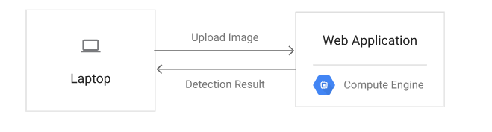

User Interface Design

Provide a sitemap and user interface design diagram for each user interface screen in the application, if not applicable, define the components of the project as described in the handbook.

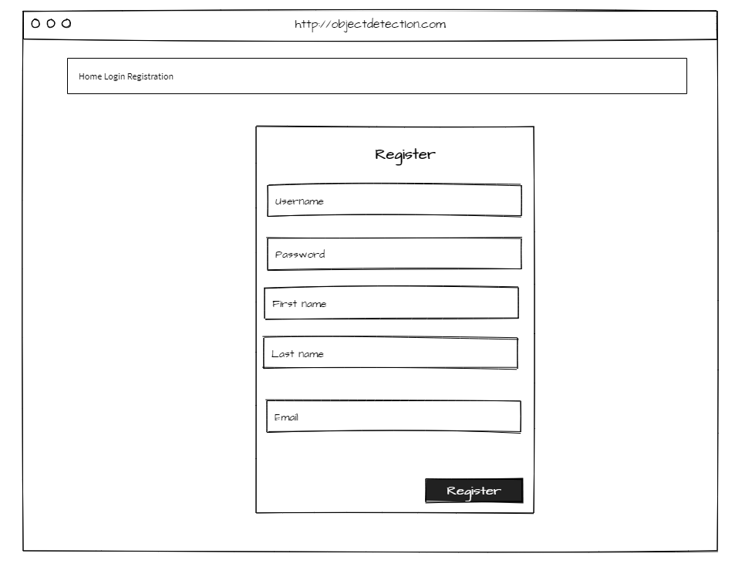

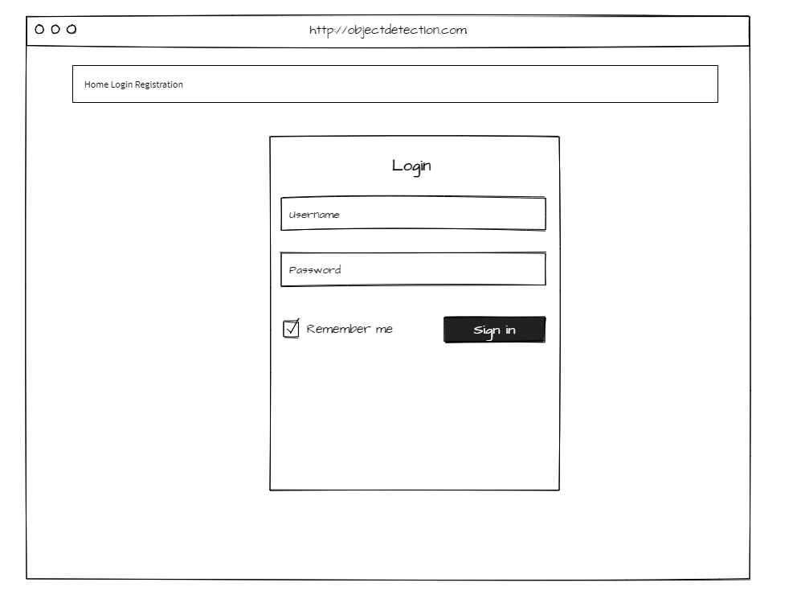

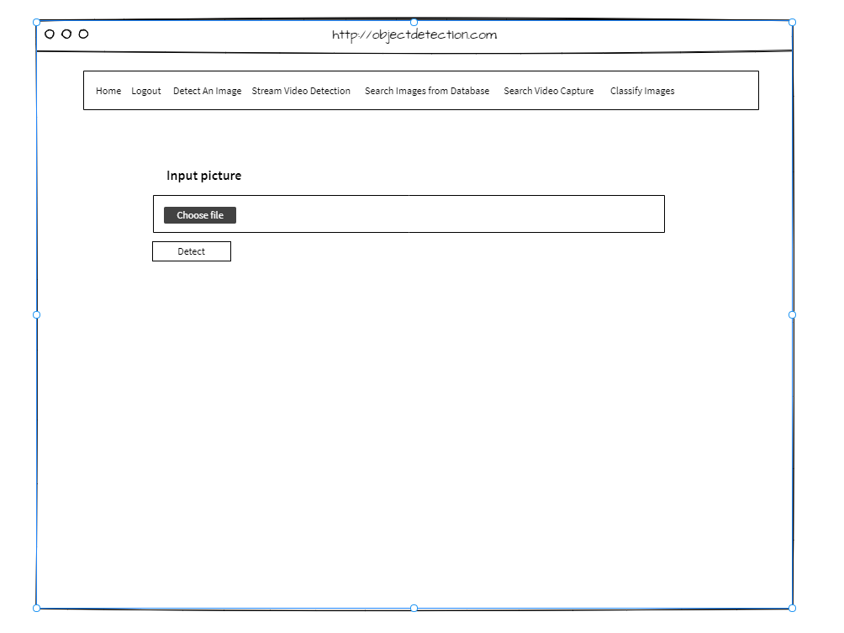

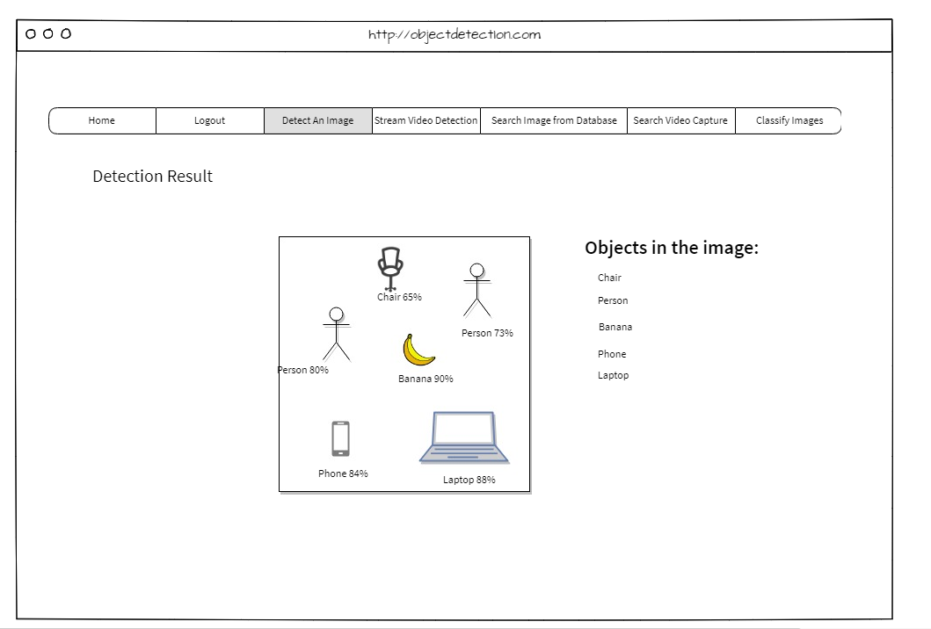

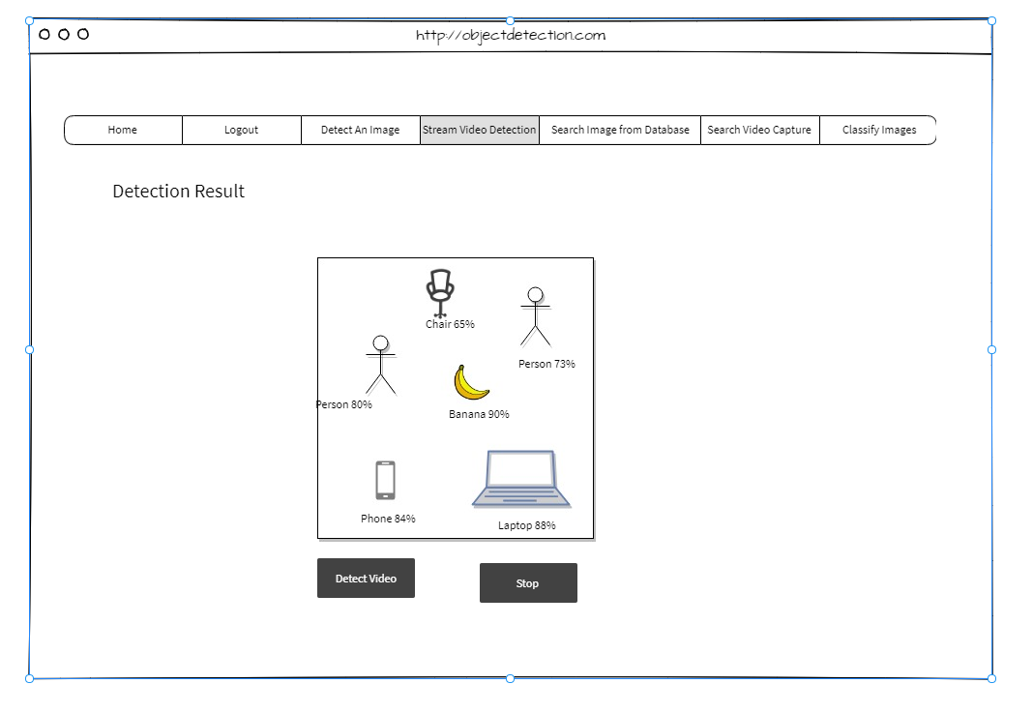

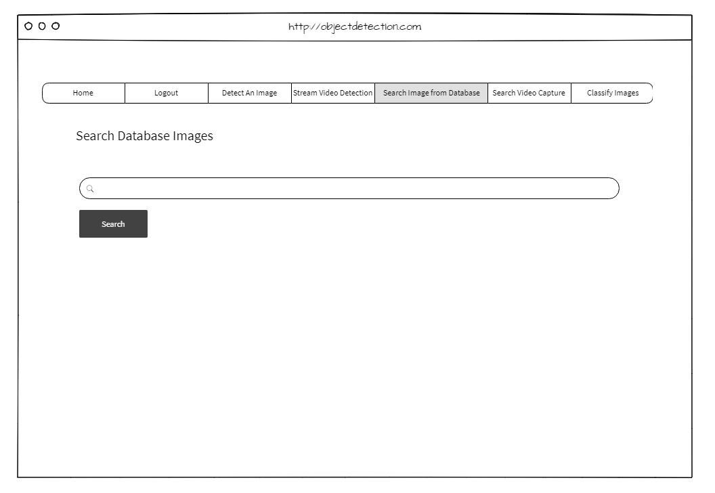

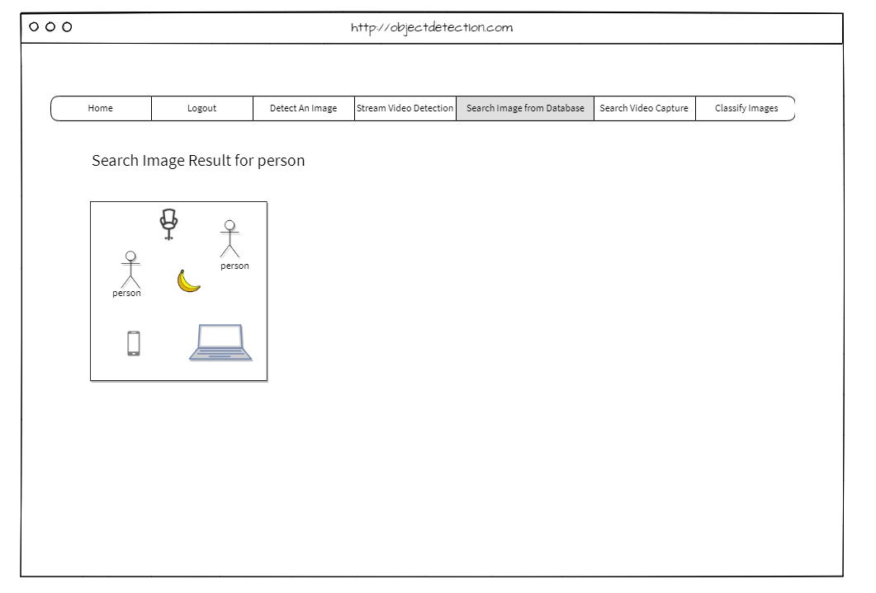

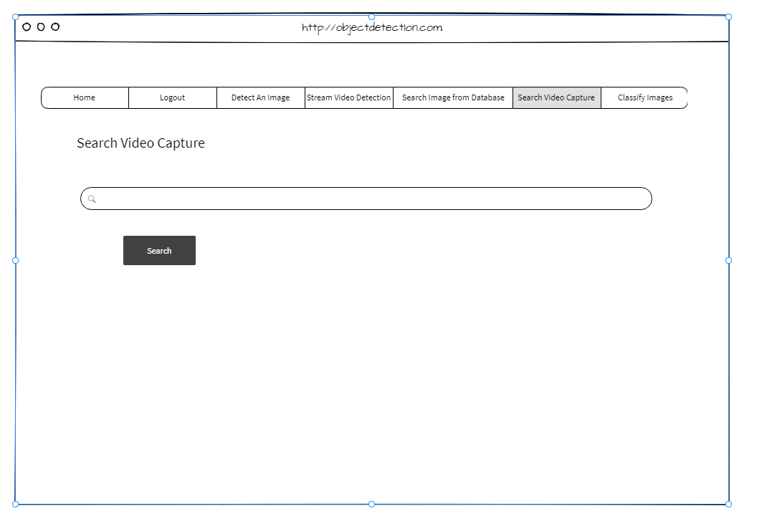

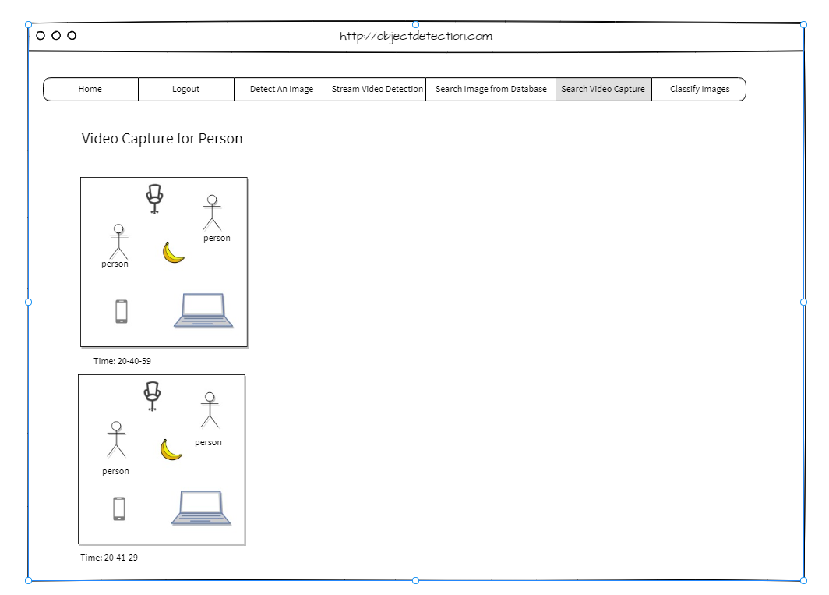

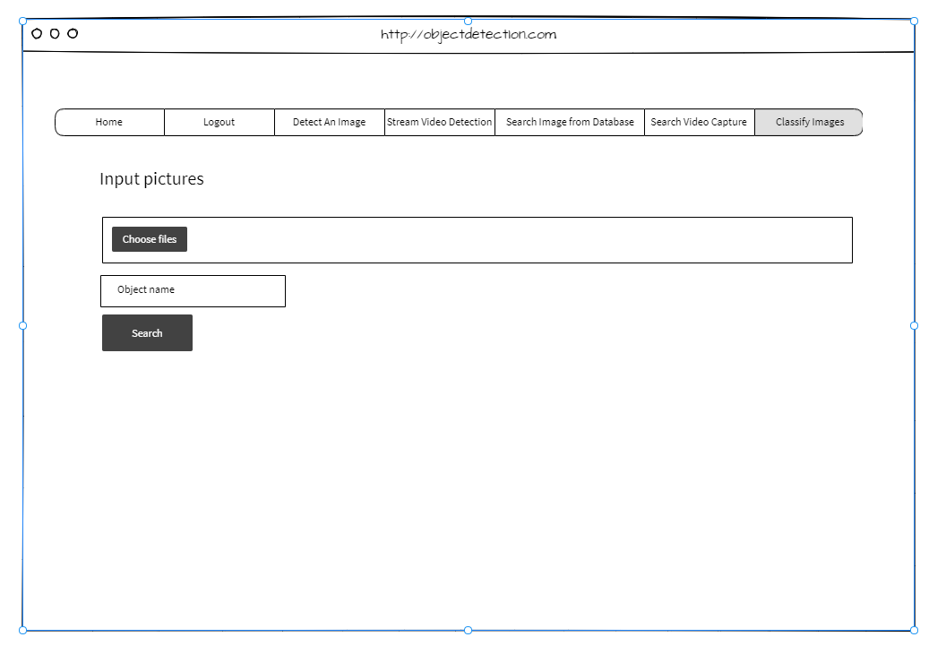

Reports Design

Provide a listing of the reports that the system will provide, if applicable. If not, state that the system does not produce any reports and provide additional documentation as described in the handbook.

There is not report design in this application.